Ho Chi Minh City University Of Transport Institute Of Information Technology and Electronics



Topic: Analysis and Design of a Library Management System
Subject: SOFTWARE ENGINEERING
Instructor: TRẦN THỊ MỸ TIÊN
List of participating students:
Name | MSSV | Complete | Task
Vũ Minh Khôi | 075207011378 | 100% | Functional, Non-Functional
Nguyễn Lê Gia Bảo | 079207018158 | 100% | Use-case Diagram
Hoàng Đỗ Gia Huy | 079206003013 | 100% | Interface Design Description
Nguyễn Dương Gia Huy | 079207014604 | 100% | Class Diagram
Phạm Minh Tân | 079207043105 | 100% | Data Model
Ho Chi Minh City, June 2026
LIBRARY MANAGEMENT SYSTEM
1. Process Description of Functional Requirements 4
1.1 Reader Management & Account Registration 4
1.2 Search and Reservation Process 4
1.3 Borrowing, Renewal, and Return 5
1.4 Staff & Role Management 5
1.5 Staff Operations at Counter 6
1.6 Statistics and Reporting Process 6
2 Process Description of Non-Functional Requirements 6
2.1 Performance & Response Time: 6
2.2 Security & Authorization: 7
2.3 Reliability & Availability: 7
2.5 Legal Compliance: 7
2.6 Cost Efficiency: 7
3. Data Flow Diagram ( DFD ) 8
3.1 Data Flow Diagrams level 0 8
3.2 Data Flow Diagrams level 1 9
3.3 Data Flow Diagrams level 2 10
4. Use Case Diagram 15
4.1 Overview 15
4.1.1 List of Actor 16
4.1.2 List of Use-case 16
4.2 Use-case Register Account 17
4.3 Use-case Log In 18
4.4 Use-case Recover Password 19
4.5 Use-case View Personal Information 19
4.6 Use-case View Registration Requests 20
4.7 Use-case Approve Reader Card Issue 20
4.8 Use-case Search Books 21
4.9 Use-case Reserve Book 22
4.10 Use-case Add to Online Wishlist 22
4.11 Use-case Remove from Online Wishlist 23
4.12 Use-case Process Borrowing 23
4.13 Use-case Verify Reader Card 24
4.14 Use-case View Borrowing History 25
4.15 Use-case Renew Books Online 26
4.16 Use-case Over-the-Counter Renewal 26
4.17 Use-case Process Return 27
4.18 Use-case Issue Fine Ticket 28
4.19 Use-case Collect Fine Payment 29
4.20 Use-case Print Receipt 29
4.21 Use-case Manage Book Catalog 30
4.22 Use-case Manage Reader Accounts 31
4.24 Use-case Statistics & Reports 32
5. Class Diagram 33
5.1 Detail Class Diagram 34
6. Data Model 35
7. Interface Design Description 36
7.1 Login Reader 36
7.2 Login Staff 40
7.3 Login Admin 44

1. Process Description of Functional Requirements

1.1 Reader Management & Account Registration
FR1.1: The system must allow users (Readers) to provide basic information including full name, date of birth, gender, Citizen Identification (ID)/Identity Card number, phone number, address, and email address (used as the login username).
FR1.2: The system must automatically check for duplicate data using the phone number, email address, or Citizen ID number against the database to prevent duplicate account creation.
FR1.3: The system must set the account status to "Active" immediately after issuing a library card (either a physical card or an in-app QR code), granting the Reader full privileges to borrow/return materials and access online services.
FR1.4: The system must temporarily lock the Reader's borrowing privileges and login access upon a rule violation, requiring library staff to manually unlock the account after the violation is resolved.
FR1.5: The system must automatically send emails, SMS messages, or in-app notifications to remind Readers 5 to 7 days before their library card expires.

1.2 Search and Reservation Process
FR2.1: Readers must be able to search for materials through a search bar using keywords such as book title, author, category, or Book ID.
FR2.2: The system must display detailed material information including abstract, bibliographic details, publication date, storage location, and review history from other Readers when a specific item is selected.
FR2.3: The system must verify account eligibility (checking for overdue fines) before confirming the book reservation process.
FR2.4: The system must send a successful reservation confirmation notification via email or app, attaching a QR code for the Reader to present to staff upon pickup.

1.3 Borrowing, Renewal, and Return
FR3.1: The system must reject a borrow transaction if the total number of currently borrowed books plus the books to be borrowed exceeds the library's prescribed limit.
FR3.2: The system must automatically calculate the return due date based on library policy (default is 14 days from the borrowing date) and record it in the loan record.
FR3.3: The system must allow Readers to renew books online, provided that the book is not reserved by another Reader, the account is not locked, there are no overdue books, and the renewal count has not exceeded 4 times per title.
FR3.4: During the return process, the system must automatically compare the actual return date with the "Due Date"; if late, the system must set the status to "Late Return".
FR3.5: The system must automatically calculate fine amounts based on business rules and generate a fine invoice containing the reason, fine amount, creation date, and a status of "Pending Payment" upon detecting a violation (late return, damaged, or lost book).

1.4 Staff & Role Management
FR4.1: Each staff member using the system must be uniquely identified by an 8-digit staff ID.
FR4.2: The system must allow Administrators (Admin) to manage staff profiles, work shifts, and assigned departments.
FR4.3: The system must implement a Role-Based Access Control mechanism.
FR4.4: The system must grant Administrators (Admin) full access privileges to all system functions.
FR4.5: The system must restrict the privileges of Circulation Staffs to only executing book issues/returns and collecting fine payments.
FR4.6: The system must restrict the privileges of Cataloging Staff to only managing book inventory and book titles.
FR4.7: The system must automatically log a System Audit Log detailing every staff operation to ensure accountability.

1.5 Staff Operations at Counter
FR5.1: The system must allow staff to scan a Reader's library card (or QR code) to retrieve account information and check their active status.
FR5.2: The system must allow staff to use a scanner to read the barcode of each book and verify its inventory status.
FR5.3: The system must allow staff to manually log the physical condition/damage level of a book after performing a physical check (torn, missing pages, or dirty) when receiving returned books.
FR5.4: The system must allow staff to confirm fine payments on the software, updating the invoice status to "Paid" and printing a receipt.
FR5.5: The system must allow authorized staff or Administrators to export report data into formats such as PDF, Excel, or CSV for archiving or formal approval submission.

1.6 Statistics and Reporting Process
FR6.1: The system must automatically collect and aggregate data across all operational sub-modules, including Reader details, book catalog, borrowing/return history, and violation/fine records.
FR6.2: The system must automatically generate periodic reports on a daily, weekly, monthly, or annual basis.
FR6.3: The system must provide a Dashboard displaying real-time visual charts of borrowing trends or new Reader registrations.
FR6.4: Based on processed data, the system must identify high-demand ("hot") book titles facing stock shortages to recommend replenishment.

2 Process Description of Non-Functional Requirements

2.1 Performance & Response Time:
+ NFR01 - Processing Speed: The system shall process barcode scanning operations for circulation within 1.5 seconds per transaction.
+ NFR02 - Search Latency: The system shall return Online Public Access Catalog (OPAC) search results within 2 seconds for a database containing up to 100,000 titles.

2.2 Security & Authorization:
+ NFR03 - Data Encryption: The system shall encrypt all user passwords and sensitive personal data.
+ NFR04 - Session Timeout: The system shall automatically terminate session access for staff accounts after 15 minutes of inactivity.
+ NFR05 - Access Control: The system shall enforce strict role-based access control requiring elevated authentication for critical operations, including deleting books, waiving fines, and exporting reports.

2.3 Reliability & Availability:
+ NFR06 - System Availability: The system shall maintain a minimum availability of 99.5% uptime during library operating hours, restricting scheduled maintenance window to off-peak hours (e.g., between 23:00 PM and 5:00 AM).
+ NFR07 - Automated Backup: The system shall perform automated daily incremental backups at 11:00 PM and weekly full backups on Sundays. All backup archives must be encrypted and securely stored on a secondary remote cloud storage to ensure data recovery in the event of hardware failure.
2.4 Scalability & Usability:
+ NFR08 - User Interface Responsiveness: The system shall provide a user-friendly interface that is fully responsive across desktop devices (for Staff) and mobile devices (for Readers).
+ NFR09 - System Integration: The system shall support integration capabilities with third-party e-payment gateways (e.g., MoMo, VNPay) and automated access control gates.

2.5 Legal Compliance:
+ NFR10 - Tax & E-Invoicing Compliance: The system shall issue electronic invoices and generate VAT tax reports automatically in compliance with Decree 123/2020/ND-CP.
+ NFR11 - Data Retention & Privacy: The system shall retain financial transaction data for at least 10 years in accordance with Accounting Law, and protect personal data under Decree 13/2023/ND-CP.

2.6 Cost Efficiency:
+ NFR12 - Environment Cost Reduction: The system architecture shall maintain development and staging environment expenses at least 60% lower than the production environment.
+ NFR13 - Software Cost Threshold: The system shall support migration to open-source alternatives if third-party software licensing fees exceed pre-defined financial thresholds.

2.7 Development Stack & Tools:
+ NFR14 - Python / C++ / Java: Used for developing backend system logic, core business operations, and database integration.
+ NFR15 - Figma: Used for designing UI/UX wireframes, interactive prototypes, and front-end interface mockups.
+ NFR16 - MySQL: Used for storing and managing centralized relational data (Readers, books, borrow/return transactions, etc.).

3. Data Flow Diagram ( DFD )

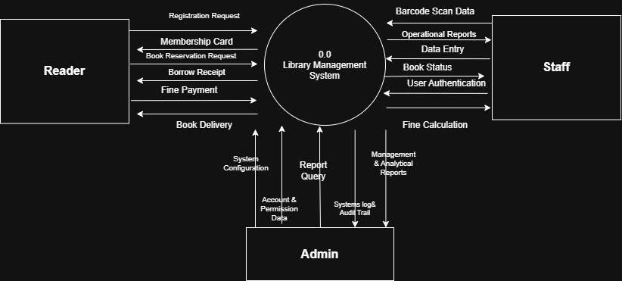
3.1 Data Flow Diagrams level 0

3.2 Data Flow Diagrams level 1
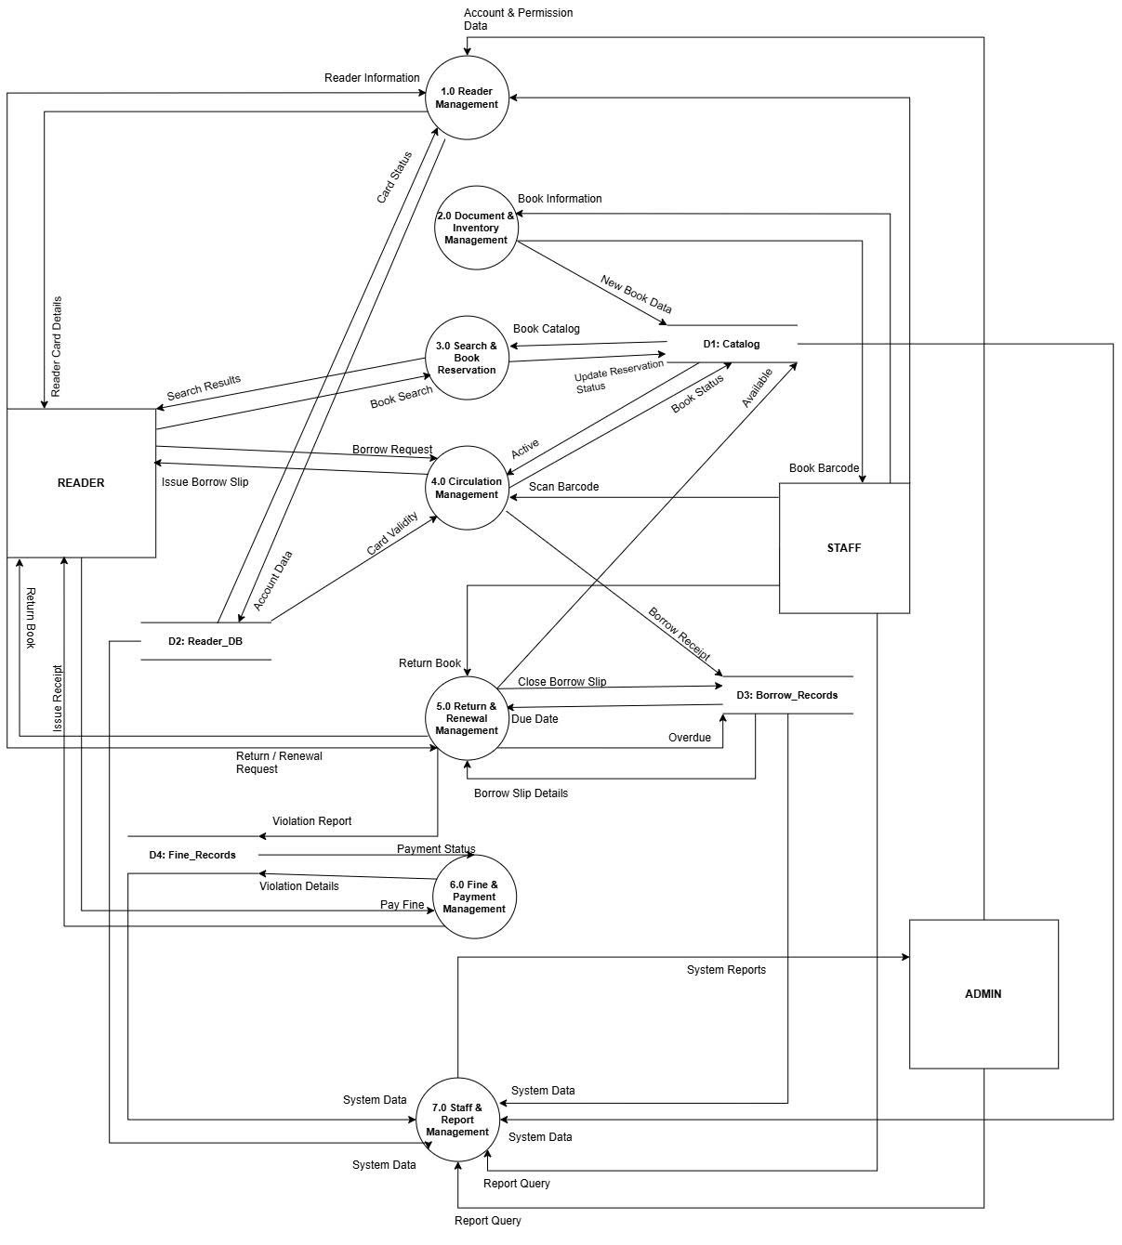

3.3 Data Flow Diagrams level 2

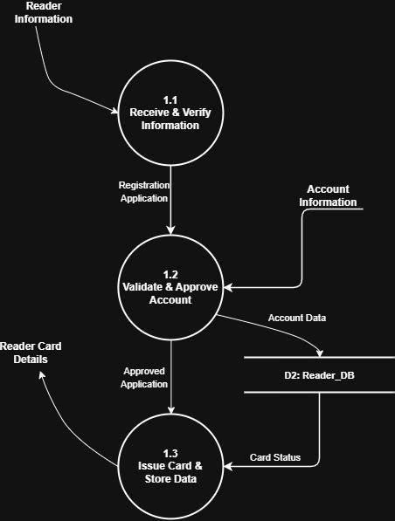
3.3.1 Reader Management

3.3.2 Document inventory management
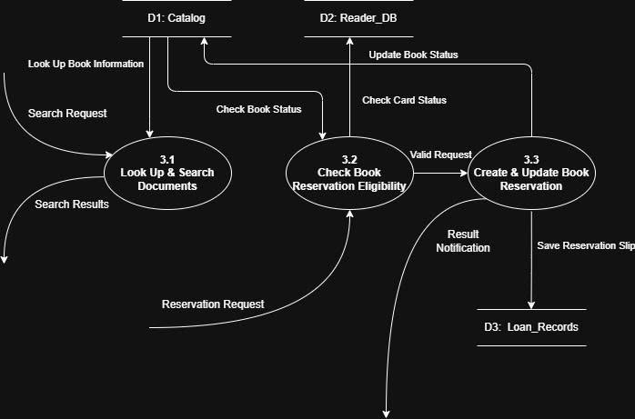
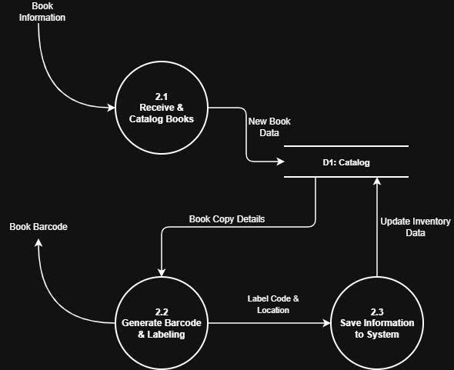
3.3.3 Search & Book Reservation

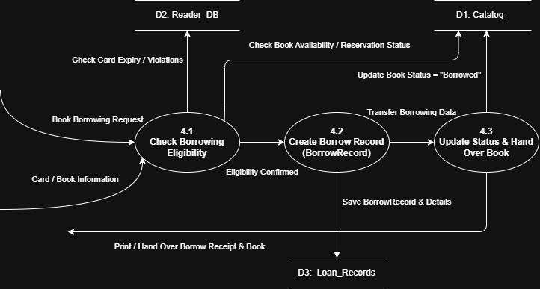
3.3.4 Circulation Management

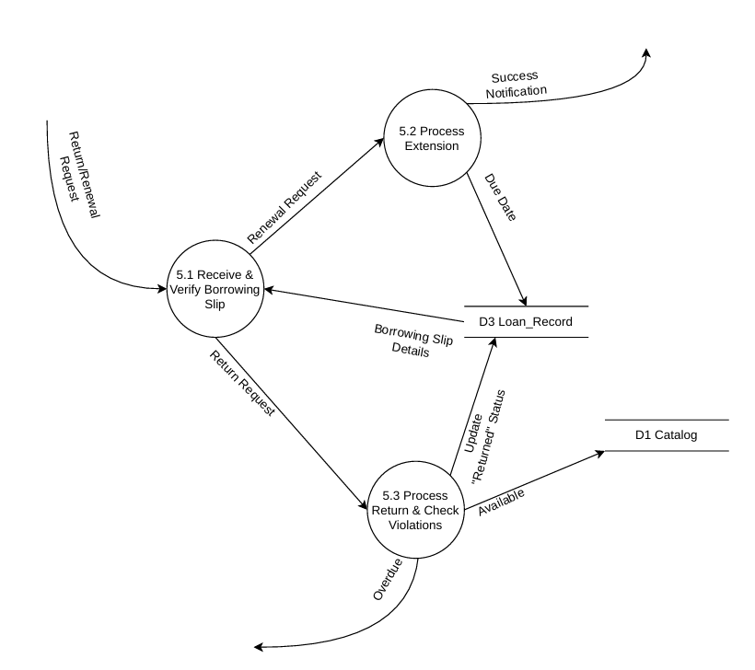
3.3.5 Return renewal management

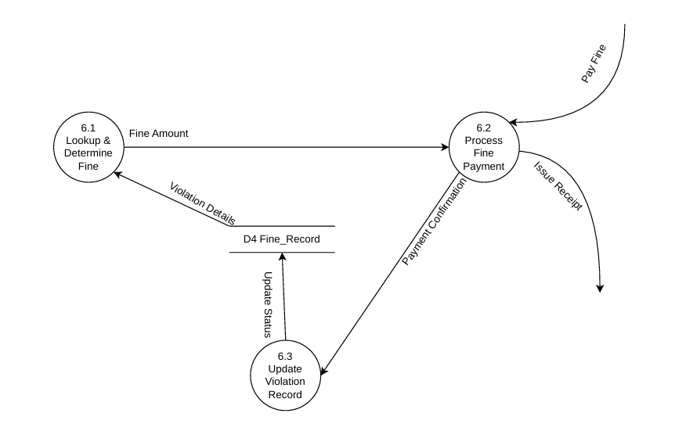
3.3.6 Fine & payment management

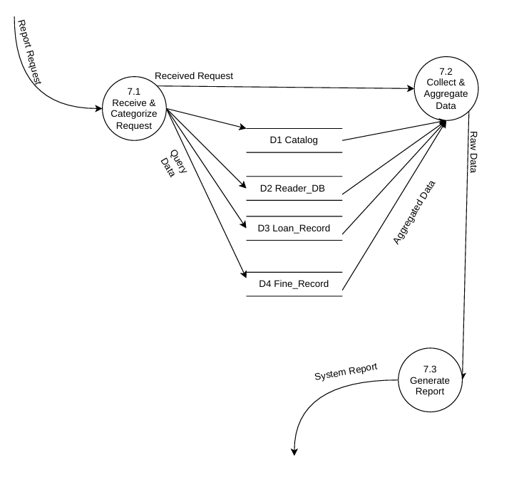
3.3.7 Staff & report management

4. Use Case Diagram

4.1 Overview

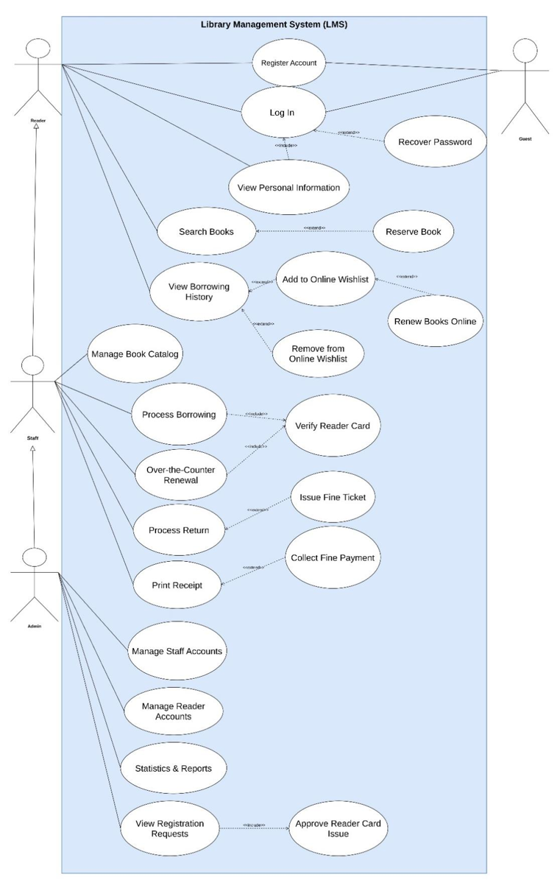

4.1.1 List of Actor
No. | Use-case | Meaning
1 | Guest | Guests or users who have not logged into the system.
2 | Reader | Registered Readers who have been issued a library card have an account to access online functions (OPAC, renewals, and holds).
3 | Staff | The staff on duty at the circulation desk is authorized to handle circulation transactions (lending and returns) and manage the collection.
4 | Admin | Senior system administrator responsible for managing library staff, configuring library policies, and approving reports.

4.1.2 List of Use-case
No. | Use-case | Meaning | Note(Group)
1 | Register Account | Sign up for a new Reader account. | 2
2 | Log in | Log in to the system | 2
3 | Recover Password | Reset forgotten password. | N/A
4 | View Personal Information | View personal profile details. | N/A
5 | Search Books | Search for library books. | 3
6 | Reserve Book | Hold a book on the shelf. | 3
7 | View Borrowing History | View past and current book borrows. | 4
8 | Add to Online Wishlist | Save favorite books to list. | 3
9 | Remove from Online Wishlist | Delete books from wishlist | 3
10 | Renew Books Online | Extend book borrow via web/app. | 5
11 | Manage Book Catalog | Add, edit, or delete books. | 1
12 | Process Borrowing | Issue physical books to Readers. | 4
13 | Over-the-Counter Renewal | Extend book borrow at the counter. | 5
14 | Verify Reader Card | Validate Reader card status. | 4
15 | Process Return | Receive returned books | 6
16 | Issue Fine Ticket | Create overdue or damage fine. | 6
17 | Print Receipt | Print transaction receipts. | 4,6
18 | Collect Fine Payment | Receive fine payment from Reader | 6
19 | Manage Staff Accounts | Add, edit, or delete staff profiles | 8
20 | Manage Reader Accounts | Edit and activate Reader accounts. | 2
21 | Statistics & Reports | View and export library reports | 7
22 | View Registration Requests | View pending sign-up requests | 2
23 | Approve Reader Card Issue | Activate card and issue QR code | 2
Group 1: Material Management Process
Group 2: Account & Card Registration Process
Group 3: Search & Reservation Process
Group 4: Borrowing Process
Group 5: Renewal Process
Group 6: Return & Fines Process
Group 7: Reporting & Analytics Process
Group 8: System Admin Management Process
N/A: System utility functions not included in the main circulation process (e.g., Change password, View personal information)

4.2 Use-case Register Account
4.2.1 Sumary: Allows visitors to register for online Reader accounts to send requests for new membership cards to the system.
4.2.2 Event stream
4.2.2.1 Main line of events
- User selects "Register account" function on OPAC interface.
- The system requires users to provide personal information: Full name, date of birth, gender, phone number, email address, CCCD number, permanent address and initialization password.
- User enters information and confirms sending request.
- The system checks the validity and compares duplicate data (avoid duplicate Emails, Phone Numbers or CCCDs in the D1: Readers database).
- The system saves the Reader profile in a pending approval state ("Pending Approval") and sends a notification of successful registration to the user.

4.2.2.2 Other event streams
- In case the login name (email) already exists: The system displays the error message "This email is already in use". Users can choose to re-enter another email or cancel registration.
- In case of missing required information: If the user is missing Full Name, Email, Phone Number, CCCD or password of less than 6 characters, the system will report a specific error in each data field for the user to modify.

4.2.3 Special requirements
- Passwords when stored in the database must be one-way encrypted using a secure hash function (Hash Function SHA-256 or higher, minimum 160 bits).
- The online registration function must integrate Captcha code to prevent data flooding by automated programs.

4.2.4 System status after performing Use-case
The registration request is successfully recorded in the Reader table in the "Pending Approval" state. System data status is updated securely.

4.3 Use-case Log In
4.3.1 Summary: Authenticate user credentials (Reader, Staff, Administrator) to grant access to corresponding system functions.
4.3.2 Flow of events
4.3.2.1 Main flow
- The user accesses the login page and provides their username (Email) and password.
- The user clicks the "Log In" button.
- The system encrypts the entered password and compares it with the encrypted data stored in the database (D1: Readers, D5: Staff, or Admin).
- If the information matches, the system grants access and redirects the user to the interface corresponding to their assigned role.
4.3.2.2 Alternative flows
Incorrect username or password: The system displays an error message stating "Incorrect username or password" (without specifying which field is incorrect to enhance security). The user may re-enter the credentials or cancel the operation.
4.3.3 System state prior to Use-case execution: The user is not logged into the system.
4.3.4 System state after Use-case execution: The user has successfully logged in and been issued an authentication token for the current session.
4.3.5 Extension points
Recover Password Use-case: The user can choose to switch to the "Forgot Password" function if they do not remember their login password.

4.4 Use-case Recover Password
4.4.1 Summary: Allows users to regain account access after forgetting their password by using their registered personal email address.
4.4.2 Flow of events
4.4.2.1 Main flow
- The user selects the "Forgot Password" function from the login screen.
- The system prompts the user to provide the email address associated with their registered account.
- The system checks the database for the existence of the email.
- If the email exists, the system automatically generates a new random password, updates the user's record in the database, and simultaneously sends an email containing the new password to the user's inbox.
- The system displays a notification asking the user to check their personal email for the new password.
4.4.2.2 Alternative flows
If the email does not exist in the system: The system displays an error message: "Email address does not exist in the system." The user may re-enter the email or exit the function.
4.4.3 Special requirements: The new password must be generated completely at random using the system's secure encryption algorithm and immediately hashed before being stored in the database.
4.4.4 System state after Use-case execution: The account's old password is invalidated, and the new random password is updated in the database.

4.5 Use-case View Personal Information
4.5.1 Summary: Users (Readers, Staffs, Administrators) access the system to view their personal details and activity history.
4.5.2 Flow of Events

4.5.2.1 Main Flow
- The user selects the "Profile" or "View Account Information" function.
- The system checks the current user's role and queries profile details from the corresponding table (Reader, Staff, or Admin).
- The system displays detailed information: full name, date of birth, phone number, email, address, account creation date, and borrowing/returning history (for Readers) or shift activity history (for staffs).
4.5.3 System state prior to Use-case execution: The user must be successfully logged into the system.

4.6 Use-case View Registration Requests
4.6.1 Summary: Allows a staff or administrator to view a list of online Reader registration applications currently awaiting approval.
4.6.2 Flow of Events
4.6.2.1 Main Flow
- The staff selects the "Approve Card Registration Request" function on the dashboard.
- The system queries the database and displays a list of Reader account registration applications with the status "Pending Approval," sorted chronologically with the most recent applications appearing first.
- The staff can click on individual applications to review details regarding personal information fields and attached documents (if any).
4.6.3 Special Requirements: The list of registration requests must be paginated to optimize page loading performance when the volume of requests is high.
4.6.4 System State Prior to Use Case Execution: The staff or administrator is successfully logged into the system.
4.6.5 Extension Points:
Use Case: Approve Reader Card Issuance – The staff selects and approves a valid application from the pending list to proceed with card issuance and official account activation.

4.7 Use-case Approve Reader Card Issue
4.7.1 Summary: Approve a valid account registration request, activate the library card, and generate an identification QR code to send to the Reader.
4.7.2 Flow of Events
4.7.2.1 Main Flow
- The staff selects the Reader profile requiring approval from the list of pending requests.
- The staff clicks the "Approve Card Issuance" button.
- The system generates a unique Reader ID (ReaderID) and automatically creates a barcode/identification QR code representing the Reader's library card.
- The system updates the Reader account status from "Pending Approval" to "Active" and sets the start and expiration dates for the library card according to established configurations.
- The system sends an approval confirmation email containing the membership card QR code image to the Reader's email address.
- The system displays a notification indicating successful approval.
4.7.3 System state prior to Use-case execution: The staff is viewing the details of the Reader's registration profile.
4.7.4 System state after Use-case execution: The Reader account status changes to "Active" in the database, and the library card is successfully activated.

4.8 Use-case Search Books
4.8.1 Summary: Allows all user types (Visitors, Readers, Staffs) to search for library materials based on various criteria.
4.8.2 Flow of Events
4.8.2.1 Main Flow
- The user selects the material search function from the search toolbar.
- The user enters search keywords (Title, Author, Category, or book code) and may optionally apply advanced filters (Publication Year, Publisher, Language).
- The system queries the D2 database (Books & BookCopies) to find records matching the keywords.
- The system displays a list of results, including: cover image, title, author, category, and the number of copies currently available on the library shelves.
- The user can choose to sort the results list (alphabetically, by entry date, or by loan count) or select an item to view details, such as the content summary and shelf location.
4.8.3 Special Requirements: Search results must be displayed instantly (response time under 2 seconds for a database of up to 100,000 titles), and the system must support searches without diacritics and approximate (fuzzy) matching.
4.8.4 Extension Points
- Reserve Book Use Case: Readers with an official account can place a reservation for a book from the book details interface.
- Add to Online Wishlist Use Case: Readers can choose to save a book to their personal wishlist.

4.9 Use-case Reserve Book
4.9.1 Summary: Allows logged-in Readers to place a hold on a book copy currently available on the shelf before visiting the library to borrow it in person, preventing it from being borrowed by someone else.
4.9.2 Flow of events
4.9.2.1 Main flow
- The Reader selects the "Place Hold" function on the details page of the book they wish to borrow.
- The system checks the Reader's account eligibility: The account must be "Active," the library card must not be expired, there must be no outstanding overdue fines, and the total number of currently borrowed books plus books on hold must not exceed the maximum allowed limit.
- The system checks the availability of the physical book copy on the shelf.
- If all conditions are met, the system changes the book copy's status from "Available" to "Reserved" and sets a hold expiration time (e.g., a maximum of 24 hours from the time the hold was placed).
- The system saves the hold information and generates a confirmation QR code, sending it to the Reader's mobile app or email.
4.9.2.2 Alternative flows
- If the Reader's account is locked or the card is expired: The system rejects the transaction and displays a notification stating the specific reason.
- If the Reader has overdue borrowed books or unpaid fines: The system displays a notification rejecting the hold request and asks the Reader to settle the fines at the counter before initiating a new transaction.
4.9.3 System state before the use case begins: The Reader is logged in and viewing the details of the book they wish to place on hold.
4.9.4 System state after the use case is completed: The book copy status is updated to "Reserved" in the database, and the successful hold is recorded in the history.

4.10 Use-case Add to Online Wishlist
4.10.1 Summary: Allows Readers to save favorite titles or those needed for future reference to a personal online list.
4.10.2 Flow of events
4.10.2.1 Main flow
- The Reader clicks the "Add to Wishlist" button on the book details page.
- The system records the association between the ReaderID and the corresponding BookID.
- The system updates the Reader's personal online Wishlist and displays the notification "Saved to Wishlist".
4.10.3 System state prior to Use-case execution: The Reader has successfully logged into the system.
4.10.4 System state after Use-case execution: The book title has been successfully added to the Reader's personal online Wishlist.

4.11 Use-case Remove from Online Wishlist
4.11.1 Summary: Allows Readers to remove book titles they are no longer interested in from their personal online wishlist.
4.11.2 Flow of Events
4.11.2.1 Main Flow
- The Reader accesses the "My Wishlist" page.
- The system displays the full list of saved book titles.
- The Reader clicks the "Delete" or "Remove" icon/button next to the corresponding book title.
- The system deletes the corresponding record link in the database.
- The system reloads the list page and displays a success notification.
4.11.3 System State Before Use Case Execution: The Reader has successfully logged in and is viewing their personal wishlist.
4.11.4 System State After Use Case Execution: The book title has been successfully removed from the personal wishlist, and the database state has been updated.

4.12 Use-case Process Borrowing
4.12.1 Summary: The core circulation desk function allows the staff to receive requests, verify constraints, and create physical book loan records for Readers.
4.12.2 Flow of Events
4.12.2.1. Main Flow
- The Reader presents their library card and the books to be borrowed at the service desk.
- The staff initiates the "Create Loan Record" function in the software.
- The staff scans the Reader's library card QR code or barcode.
- The system automatically verifies the library card status.
- Once the card is validated, the staff uses a barcode scanner to scan the barcode (CopyID) affixed to each physical book being borrowed.
- The system checks the availability of each book copy in the database and verifies the Reader's borrowing limits (ensuring the maximum allowed quantity is not exceeded).
- The staff reviews the information displayed on the screen and clicks "Confirm Loan."
- The system initiates a new loan transaction in the database: it creates a BorrowRecord (containing the transaction ID, Reader ID, loan date, and processing staff ID) and creates BorrowDetail records corresponding to each borrowed book (setting the DueDate to 14 days from the loan date, per general policy).
- The system updates the status of the book copies in the BookCopy table from "Available" to "On borrow" and simultaneously decrements the available stock count.
4.12.3 Special Requirements: The entire process of scanning codes and processing loan transactions must ensure data integrity (utilizing a transaction mechanism so that if a single loan detail fails, the entire transaction is rolled back to prevent data inconsistency). The barcode scanning response time must be less than 1.5 seconds.
4.12.4 System state prior to Use-case execution: The staff has successfully logged into the system and is working on the loan slip creation screen.
4.12.5 System state after Use-case execution: The loan slip has been successfully created; book status data and the Reader's borrowing limits have been instantly updated in the database.
4.12.6 Extension point
Print Receipt Use-case: The system automatically proceeds to the physical loan slip printing flow for the Reader to sign and confirm after the borrowing transaction is completed.

4.13 Use-case Verify Reader Card
4.13.1 Summary: The system automatically reviews and checks the validity and potential constraint violations of the Reader's library card before allowing subsequent circulation transactions to proceed.
4.13.2 Flow of events
4.13.2.1 Main flow
- The system receives the ReaderID from the book borrowing or renewal process.
- The system checks the Reader card's expiration date (CardExpiryDate) against the current date.
- The system checks the card's operational status in the database (it must be "Active").
- The system counts the number of books currently borrowed and unreturned by the Reader (using the BorrowDetail table) and compares this against the maximum borrowing limit allowed for the Reader's category (e.g., Student, Faculty).
- The system checks if the Reader has any overdue books (past the due date) or any outstanding penalty invoices marked as "Pending Payment."
- If all checks pass, the system returns a successful validation result and displays a summary of the Reader's information on the staff's interface.
4.13.2.2 Alternative flows
- If the card is expired or temporarily blocked: The system emits a warning sound and displays an error message detailing the reason for rejection on the staff's screen. The use case terminates.
- If the Reader holds overdue books or has unpaid penalties: The system reports a circulation policy violation and blocks the Reader from borrowing new books until the violation is resolved.
4.13.3 System state prior to use case execution: The system has received the Reader's library card ID as input from a circulation process.

4.14 Use-case View Borrowing History
14.1. Summary: Allows the Reader to view their complete borrowing and return history via their online OPAC account.
14.2. Flow of Events
14.2.1. Main Flow
- The Reader selects the "Borrowing History" function on their personal account management page.
- The system queries the BorrowRecord and BorrowDetail tables, filtering by the ReaderID of the currently logged-in Reader.
- The system displays a list of all borrowing transactions, sorted chronologically from newest to oldest. Information displayed for each book includes: Title, Borrow Date, Due Date, Actual Return Date (if applicable), status (On Loan, Returned, Overdue), and any incurred fines.
14.3. System State Prior to Use-Case Execution: The Reader has successfully logged into the system.
14.4. Extension Points
"Renew Books Online" Use-Case: The Reader can click the "Renew" button next to any book currently "On Loan" that is eligible for renewal.

4.15 Use-case Renew Books Online
4.15.1 Summary: Readers can renew their book loans online via the mobile app or web interface without needing to bring the books to the library in person.
4.15.2 Flow of events
4.15.2.1 Main flow
- The Reader accesses the screen displaying the list of currently borrowed books.
- The Reader clicks the "Renew Online" button next to the specific book they wish to renew.
- The system automatically checks a series of renewal constraints: o The book is not currently reserved by another Reader in the system. o The Reader's account is not locked, there are no other overdue borrowed books, and there are no outstanding fines. o The number of renewals for this book has not exceeded the library's maximum limit (maximum of 4 consecutive renewals per title).
- If all conditions are met, the system updates the new due date for the corresponding loan record (the new due date is set to 14 days after the original due date) and increments the renewal count by one.
- The system displays a "Renewal Successful" notification, clearly showing the new due date to the Reader.
4.15.2.2 Alternative flows
- If the book is reserved by someone else or renewal constraints are violated: The system displays a renewal rejection notification with the specific reason (e.g., "Book is already reserved" or "You have exceeded the allowed number of renewals"). The book's original due date remains unchanged.
4.15.3 System state prior to Use-case execution: The Reader has successfully logged in and is currently on the interface for managing their borrowed book history.
4.15.4 System state after Use-case execution: The due date for the borrowed book is updated to 14 days later in the database, and the transaction history records the new status.

4.16 Use-case Over-the-Counter Renewal
4.16.1 Summary: The staff receives the request and processes the book loan extension directly for the Reader at the circulation desk.
4.16.2 Flow of Events
4.16.2.1 Main Flow
- The Reader brings the book or their library card to the desk to request a due date extension.
- The staff scans the Reader's library card to verify their account status.
- The staff scans the barcode of the book the Reader wishes to renew.
- The system checks business constraints similar to the online process (e.g., the book has no pending reservations, the Reader has no other overdue books, and the renewal count has not exceeded four times).
- The staff clicks the "Confirm In-Person Renewal" button.
- The system executes a transaction to update the due date in the database's BorrowDetail table, extending it by 14 days.
- The system displays a successful renewal notification on the staff's screen.
4.16.3 System State Before Use-Case Execution: The staff is logged in and positioned at the circulation desk interface.
4.16.4 System State After Use-Case Execution: The book's new due date has been successfully updated in the database.
4.16.5 Extension Points
- Print Receipt Use-Case: The system prints a receipt confirming the new due date for the Reader's records.

4.17 Use-case Process Return
4.17.1 Summary: The staff receives physical books returned by Readers at the counter, completes the return transaction, and checks for any violations.
4.17.2 Flow of events
4.17.2.1 Main flow
- The Reader brings the physical book to the circulation counter to return it.
- The staff opens the "Book Return" screen in the software.
- The staff scans the barcode (CopyID) affixed to the physical book.
- The system automatically searches for the active loan record (BorrowDetail) corresponding to the scanned barcode to retrieve the ReaderID, DateBorrow, and DueDate.
- The staff physically inspects the book (checking pages for tears, stains, scribbles, missing pages, or a torn cover).
- The staff records the book's actual condition upon return in the software (e.g., "Intact," "Torn cover," "Missing pages," "Lost book").
- The system updates the "Actual return date" field in the BorrowDetail table with the current date.
- The system updates the status of the book copy in the BookCopy table from "On borrow" back to "Available" and increments the available shelf inventory count for that book title.
- The system removes the returned book from the Reader's list of currently borrowed items.
4.17.3 System state before starting the use case: The staff has successfully logged in and is working within the book return processing interface.
4.17.4 System state after executing the use case: The return transaction is recorded, and the physical book's status in the inventory is restored to "Available" for future loans.
4.17.5 Extension points
- "Issue Fine Ticket" use case: Automatically triggered when the system detects that the actual return date is later than the scheduled due date, or when the staff records a returned book as torn, missing pages, or lost.
- "Print Receipt" use case: The system automatically prints a return confirmation slip for the Reader upon completion.

4.18 Use-case Issue Fine Ticket
4.18.1 Summary: Generate a library violation fine record when a Reader returns a book late, damages it, or loses it, and apply the corresponding penalty.
4.18.2 Flow of Events
4.18.2.1 Main Flow
- The system automatically calculates the number of overdue days (if applicable): OverdueDays = ActualReturnDate - DueDate.
- The system applies automatic fine calculation rules based on library policy to determine the specific fine amount (e.g., 5,000 VND per overdue day).
- For cases of physical damage (torn cover, graffiti, missing pages, lost book) entered by the staff, the system applies compensation rates based on the established schedule of charges.
- The system automatically creates a new fine record in the FineReceipt table, including: FineID, original loan transaction ID, detailed violation description, total fine amount, and creation date; it sets the fine status to "Pending Payment."
- The system automatically updates the Reader's account status in the Reader table to "Temporarily Suspended," blocking all future borrowing or renewal privileges until the fine is paid.
- The system displays detailed fine information on the staff's screen and sends a fine payment reminder via email or the Reader app.
4.18.3 System State Before Use Case Execution: The system detects a deadline violation or an issue with the book's condition during the return process at the counter.
4.18.4 System State After Use Case Execution: The violation fine record is successfully saved to the database with a "Pending Payment" status, and the Reader's account is securely suspended across the system.
4.18.5 Extension point
"Collect Fine Payment" use case: The staff collects fine payments directly from the Reader at the circulation desk to clear outstanding fine balances.

4.19 Use-case Collect Fine Payment
4.19.1 Summary: Accept fine payments from Readers in violation, update the invoice status to "Paid," and restore the Reader's card privileges.
4.19.2 Flow of Events
4.19.2.1 Main Flow
- The Reader pays in cash at the counter or makes a bank transfer.
- The staff searches for the Reader's fine slip code in the fine management software.
- The staff verifies the amount due and clicks the "Confirm Fine Payment" button.
- The system updates the fine slip status in the FineReceipt table from "Pending Payment" to "Paid" and records the actual payment date and the processing staff's ID.
- The system automatically checks if the Reader has any other unpaid fine slips. If the Reader has cleared all outstanding fines, the system automatically changes the Reader's card status in the Reader table from "Temporarily Suspended" back to "Active."
- The system displays a notification confirming the successful payment update.
4.19.3 System State Before Use-Case Execution: The Reader has a fine slip with an unpaid status, and the staff has selected the correct fine slip to process.
4.19.4 System State After Use-Case Execution: The fine slip status is updated to "Paid" in the database, and the Reader's account is unblocked, restoring normal borrowing privileges.
4.19.5 Extension Points
- Print Receipt Use-Case: The system prints a fine payment receipt to provide to the Reader for reconciliation purposes.

4.20 Use-case Print Receipt
4.20.1 Summary: Print a physical receipt at the counter to serve as proof of transaction completion (book loan slip, book return slip, or fine payment receipt) and hand it to the Reader.
4.20.2 Flow of Events
4.20.2.1 Main Flow
- A circulation transaction (book loan, book return, or fine collection) is successfully confirmed in the system.
- The system sends formatted receipt data (containing the transaction ID, Reader's name, list of books/violations, amount, timestamp, and staff's name) to the dedicated thermal printer connected at the counter.
- The printer successfully outputs the physical receipt for the Reader and logs the printing event in the system log file.
4.20.3 System State Prior to Use Case Execution: The corresponding circulation transaction has been successfully recorded and stored in the database.

4.21 Use-case Manage Book Catalog
4.21.1 Summary: Enables staffs and administrators to manage the lifecycle of library books and materials, including functions to add new items, update information, and delete books.
4.21.2 Flow of Events
4.21.2.1 Main Flow
- The user selects the "Book Catalog Management" function on the system interface.
- The system displays the complete list of existing book titles along with advanced search and filtering tools.
- The user may select one of the following actions:
- Add new book title: Enter the book's metadata (title, publication year, author information, publisher, category). The system checks for duplicate information, adds the new data to the "Book" table, automatically generates a copy code (CopyID), and prints a barcode label.
- Update book: Select the book title to be modified, edit publication details or the quantity of copies available on the shelf, and then click confirm to save the new information to the database, overwriting the old data.
- Delete book: Select the book title or physical copy to be deleted (e.g., due to damage or obsolescence requiring disposal); the system requests confirmation of the deletion action.
4.21.2.2 Alternative Flows:
- Deletion blocked by foreign key constraint: If the user attempts to delete a book that has a recorded borrowing/returning history, the system detects a foreign key constraint (RESTRICT rule from the loan details table) and prevents physical deletion to maintain data integrity. The system displays a warning error message and automatically guides the user to change the book's status to "Liquidation" (Soft Delete), hiding it from the OPAC while preserving transaction history.
4.21.3 System state prior to Use-case execution: The Staff or Admin is successfully logged into the system and possesses the authority to manage the document catalog.
4.21.4 System state after Use-case execution: The book catalog database (D2: Books & BookCopies) is updated, and the modifications are successfully recorded.

4.22 Use-case Manage Reader Accounts
4.22.1 Summary: Allows staffs and administrators to manage Reader profile information, approve profile modifications, and control the activation/lock status of Reader cards.
4.22.2 Flow of events:
4.22.2.1 Main flow:
- The user accesses the "Reader Account Management" function within the administration software.
- The system displays a list of all Readers in the database, accompanied by account status filters ("Active", "Pending", "Suspended").
- The user performs management actions:
- Update profile: Modify contact information (permanent address, phone number, email) based on Reader requests and extend the library card's validity period.
- Manually lock account: Proactively change the Reader status to "Locked" (card locked) in cases of serious library rule violations, reported lost cards, or requests to discontinue service.
- Unlock account: Change the Reader status back to "Active" after the Reader has resolved policy violations or paid required fines.
4.22.3 Special requirements: The displayed list of Readers must be fully paginated to ensure optimized database query speed.
4.22.4 System state prior to Use-case execution: The user has successfully logged into the system and possesses the necessary permissions for Reader account management.
4.22.5 System state after Use-case execution: The Reader information database (D1: Readers) has been successfully updated with the new status.

4.23 Use-case Manage Staff Accounts
4.23.1 Summary: High-privilege Administrator (Admin) functionality used to manage personnel records, issue operational accounts, and assign permissions to library staff.
4.23.2 Flow of Events:
4.23.2.1 Main Flow:
- The Administrator (Admin) logs into the system and selects the "Staff Account Management" function.
- The system displays a list of current library staff, including details on their positions and departments.
- The Admin performs the following actions:
- Issue new account: Enter personnel details (full name, date of birth, gender, ID card number, position, base salary) and assign a username and initial system password.
- Role Assignment: Assign specific operational permissions to staff (e.g., Circulation Staff, Cataloging/Collection Management Staff, or Financial Reporting Staff).
- Deactivate account: Change the staff account status to "Inactive" or delete the account upon staff resignation to revoke all access to the library system.
4.23.3 System state prior to Use-case execution: The Administrator is logged into the system with full administrative privileges (Admin).
4.23.4 System state after Use-case execution: The library staff database (D5: Staffs) is accurately updated, and all permission changes take effect immediately upon the next login session.

4.24 Use-case Statistics & Reports
4.24.1 Summary: Supports the generation of detailed statistics, visualizations of book circulation activity, and financial reports on fines for library management.
4.24.2 Flow of Events:
4.24.2.1 Main Flow:
- The user (Staff or Admin) selects the "Statistics & Reports" function on the management screen.
- The user selects the desired report type: o Daily/weekly circulation report (borrowing and returning) (used by staffs). o List of overdue, unreturned books. o Financial report on fine revenue (used by Admins). o Statistics on borrowing frequency by category to support new material acquisition.
- The user configures the time range for filtering the data to be reported.
- The system queries data from all data repositories (D1, D2, D3, D4), calculates statistical indicators (KPIs), and displays visual data tables on the screen.
- The user can select the "Export Report" function to generate standard PDF files or Excel spreadsheets for printing, sharing, or archiving.
4.24.3 Special Requirements: The data statistics process operates strictly in "Read-only" mode; it must not perform any operations that overwrite or alter the static data state of database tables, ensuring absolute data integrity.
4.24.4 System State Prior to Use-Case Execution: The user has successfully logged in and possesses the appropriate permissions to view statistical reports.

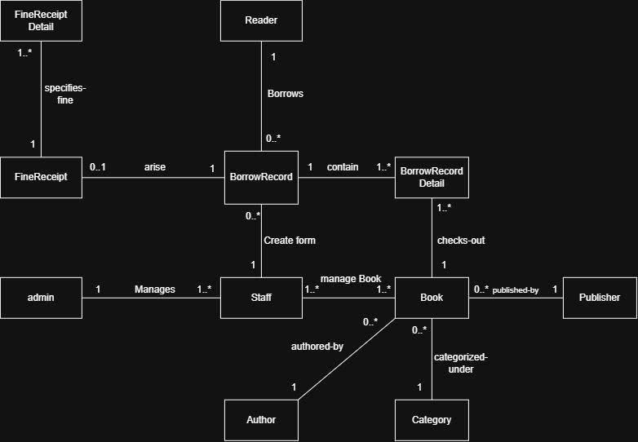
5. Class Diagram

5.1 Detail Class Diagram
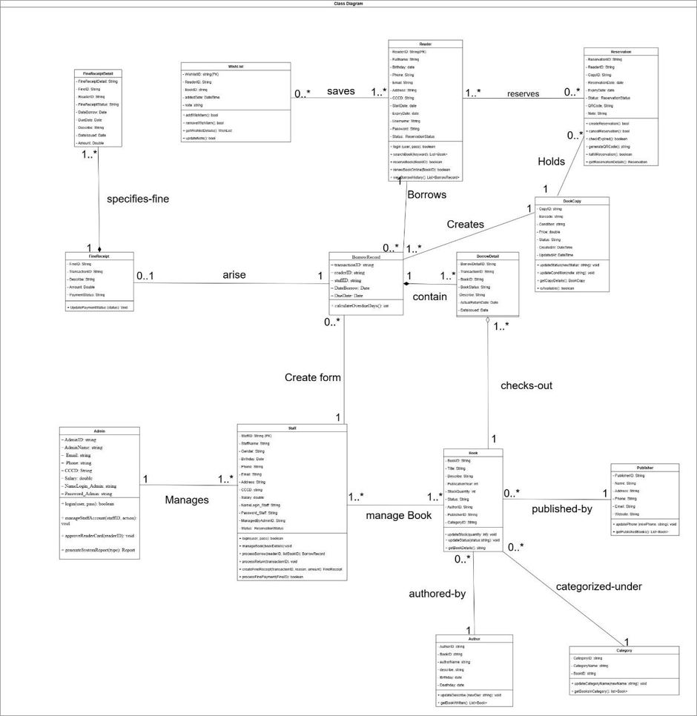

6. Data Model
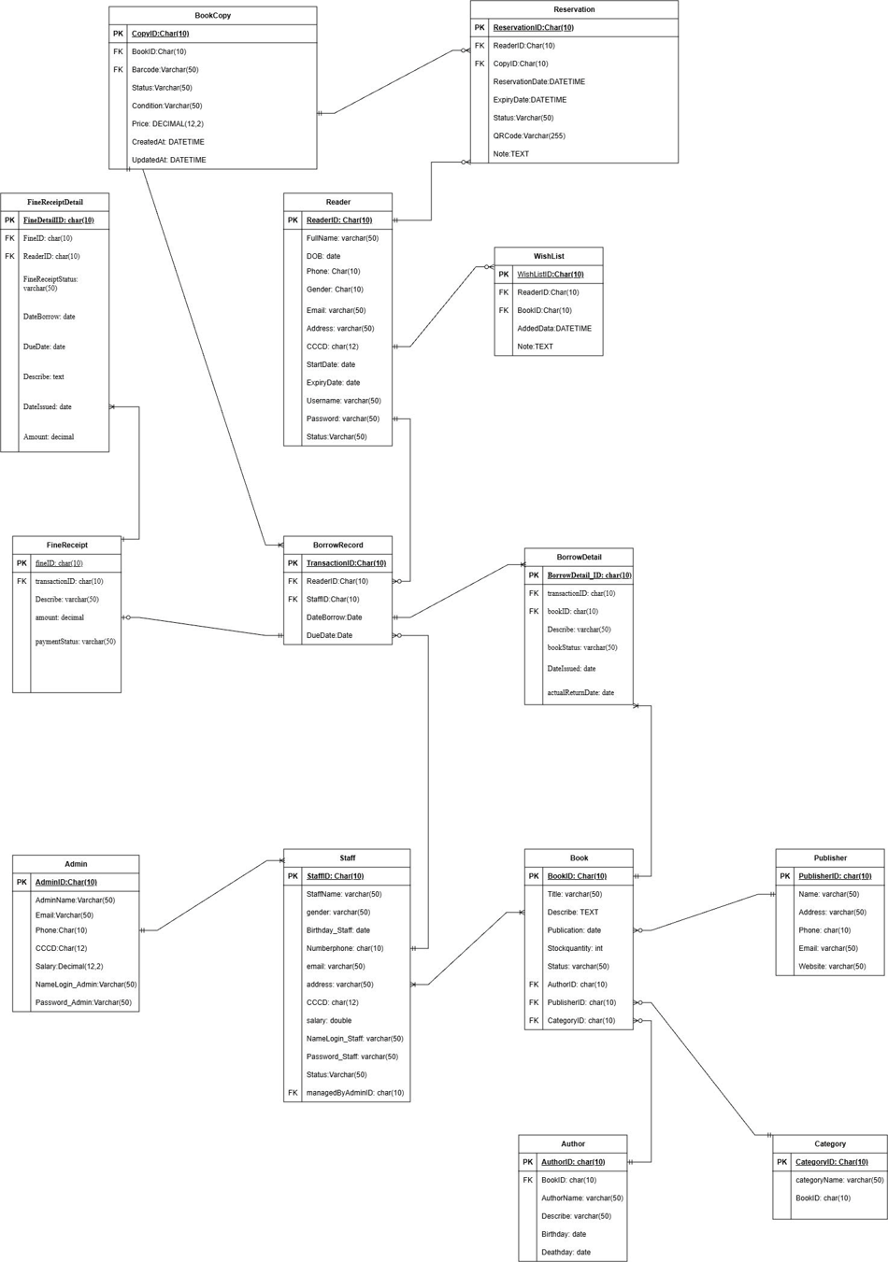

7. Interface Design Description

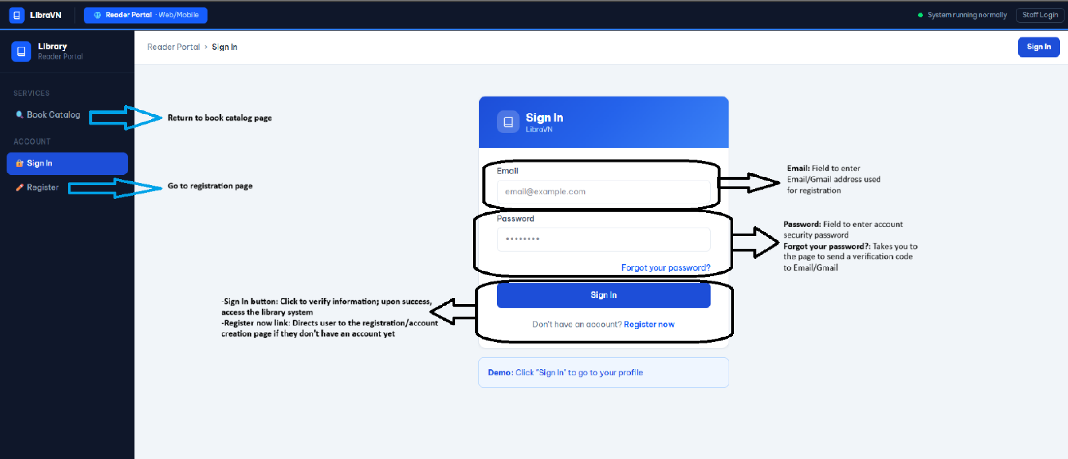
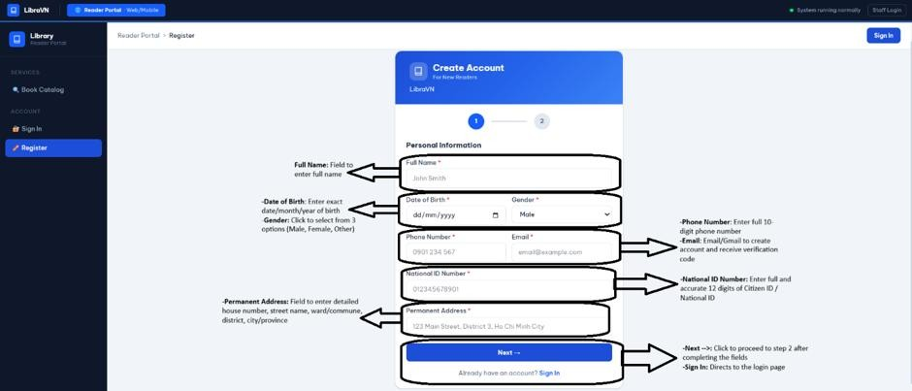
7.1 Login Reader
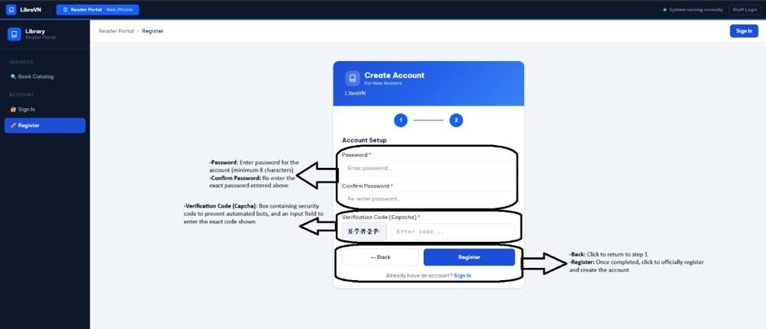
7.1.1 Log In

7.1.2 Homepage Reader
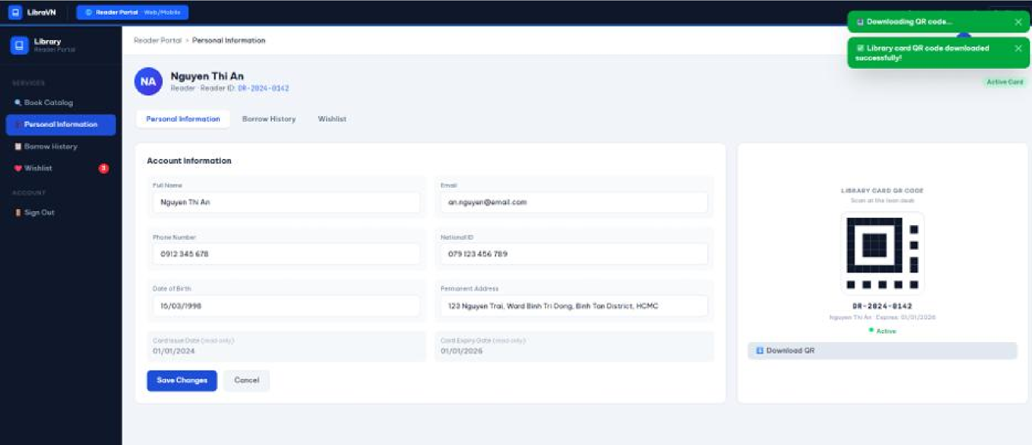

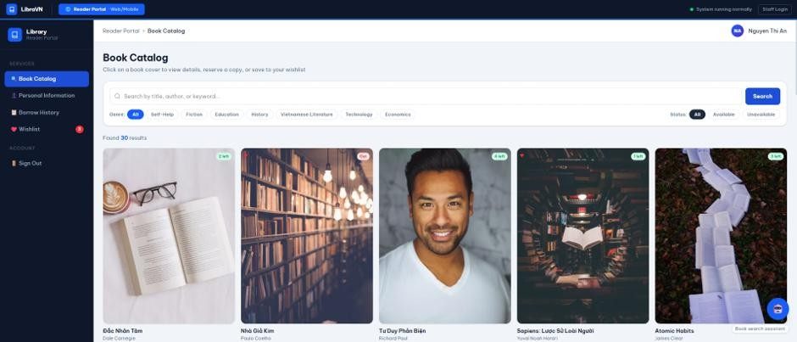
7.1.3 Search Book


7.1.4 Reverse book

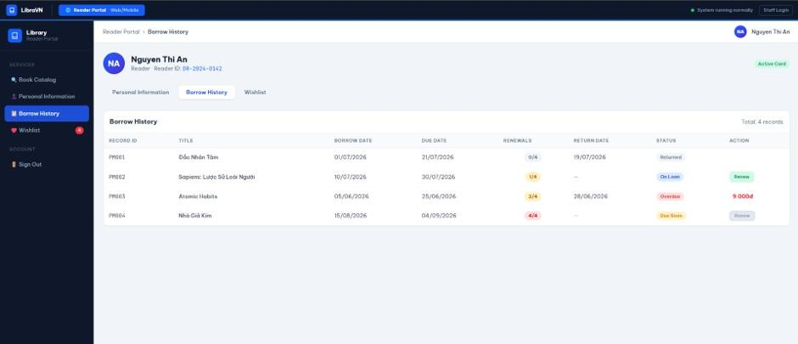
7.1.5 Borrow History

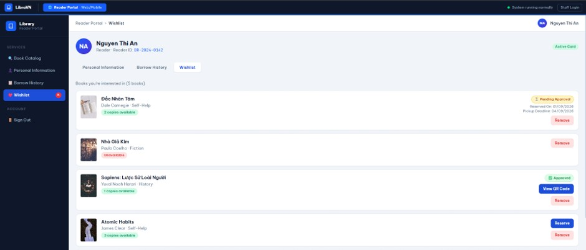
7.1.6 Wishlist

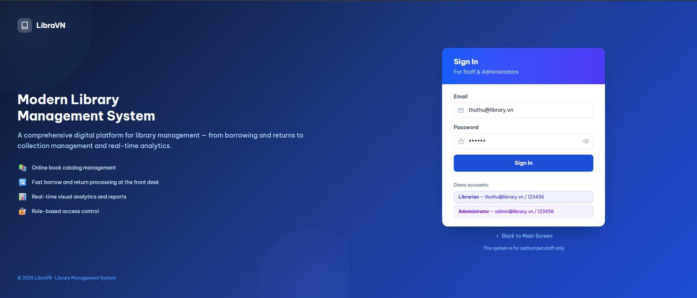
7.2 Login Staff
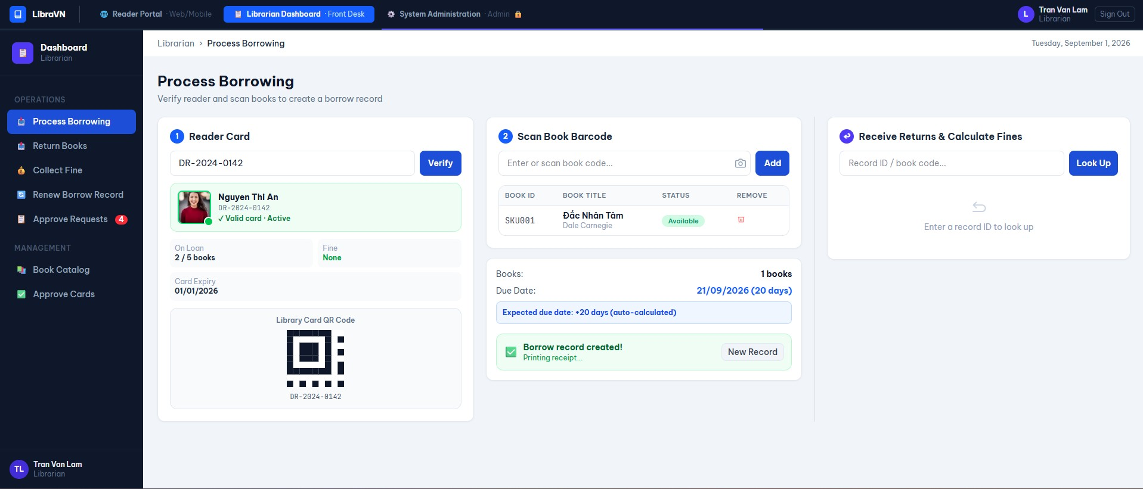
7.2.1 Homepage Staff

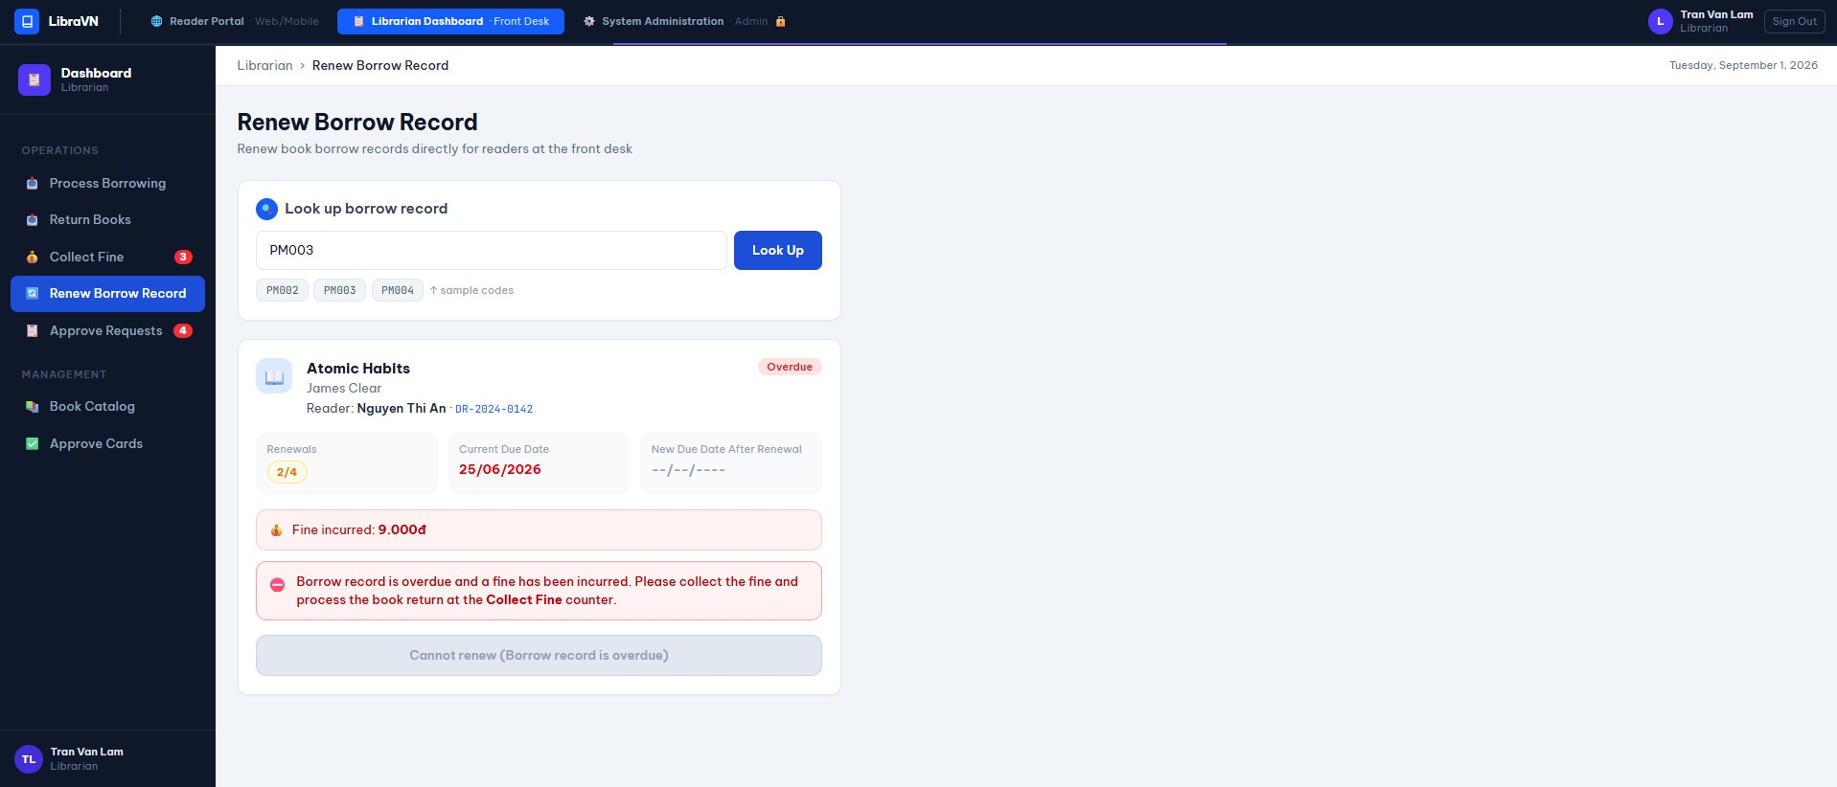
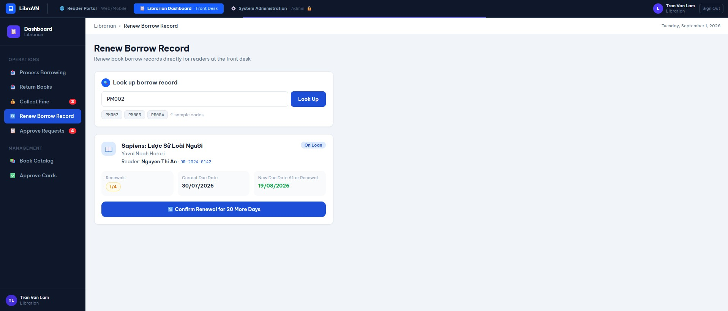
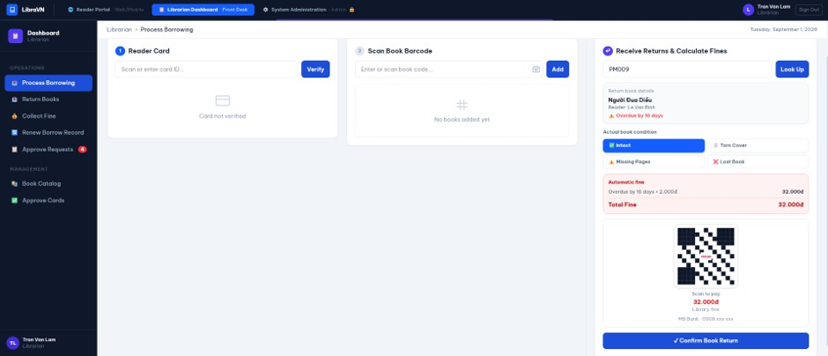
7.2.1 Renew Borrow Record Staff
7.2.2 Return Books
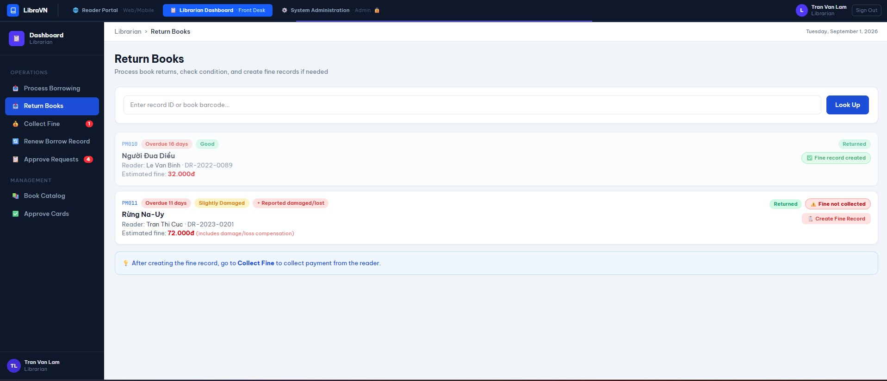
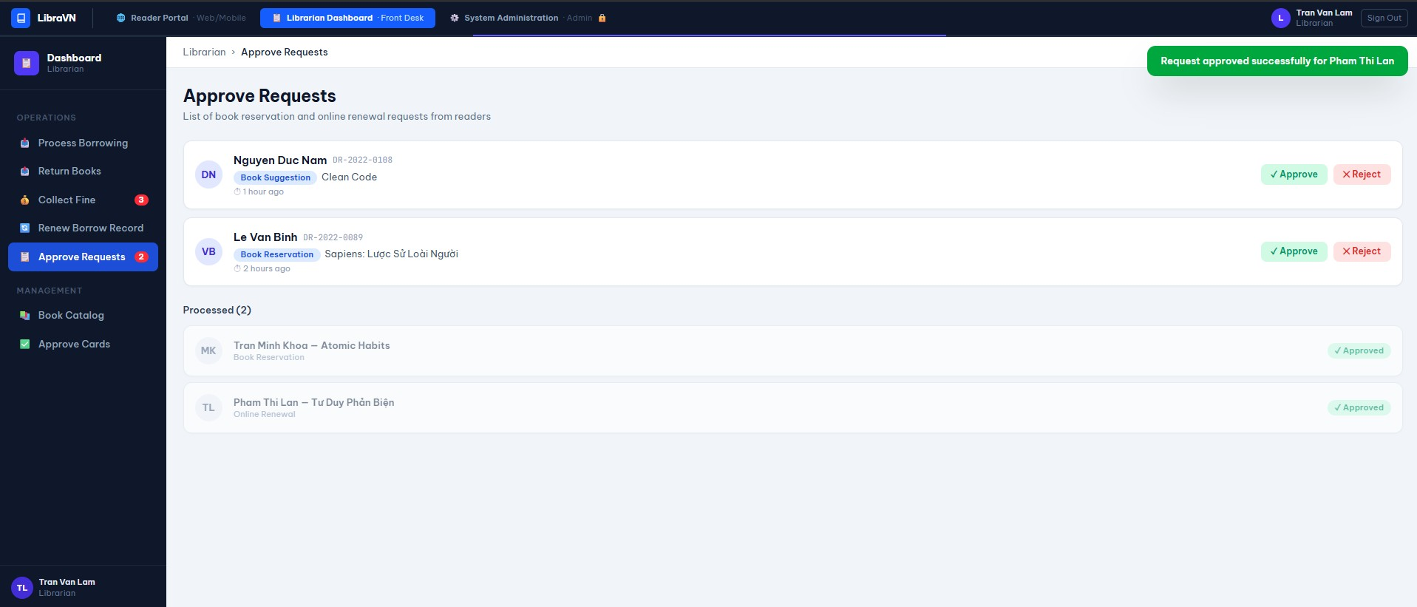
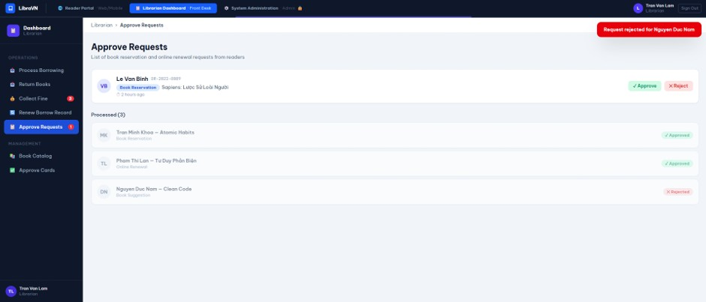
7.2.3 Approve Requests
7.2.4 Book Catalog Management
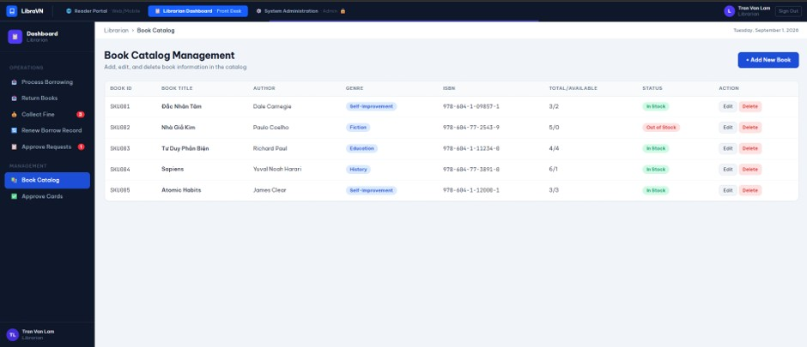
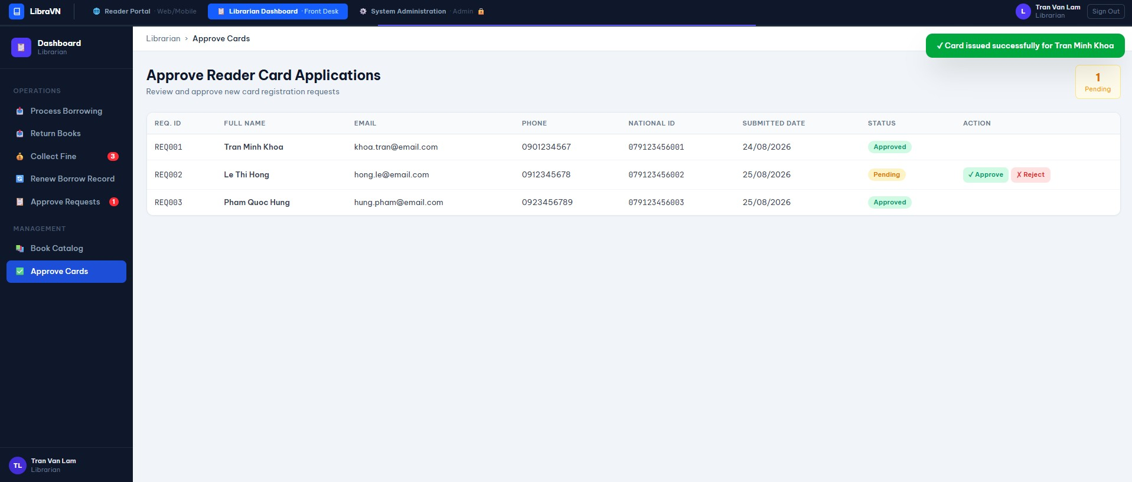
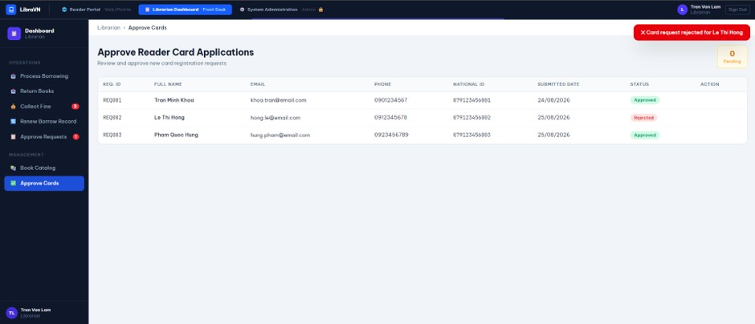
7.2.5 Approve Reader Card Applications

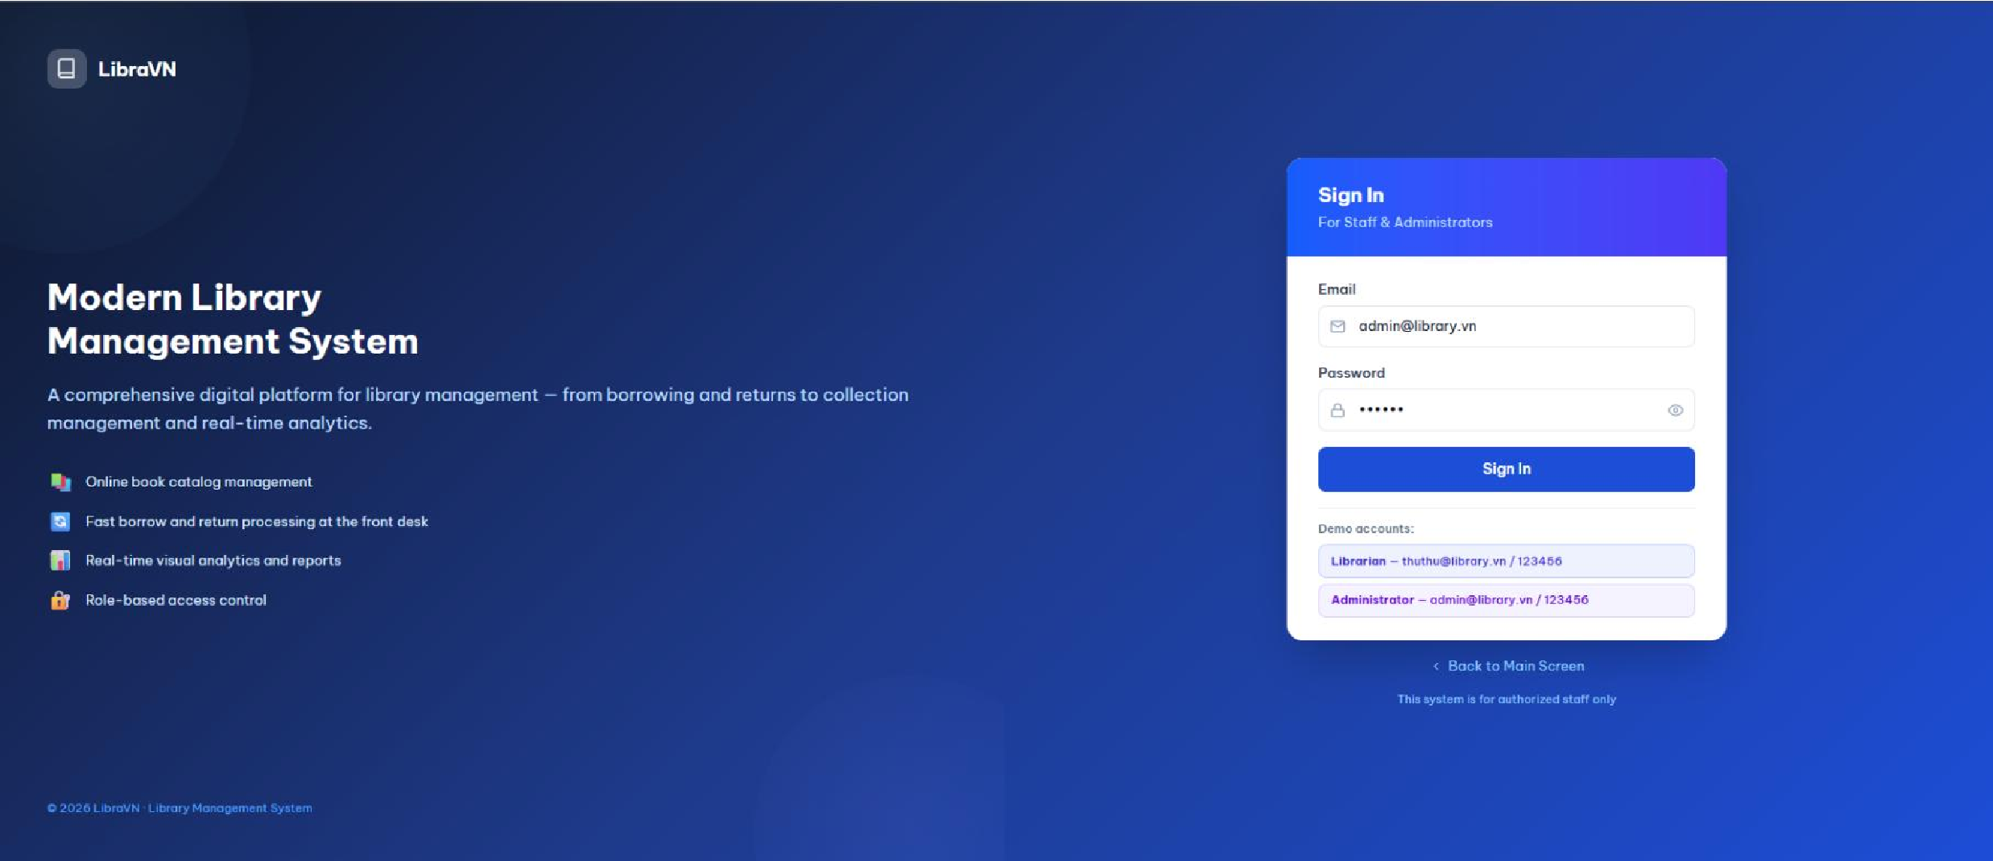
7.3 Login Admin

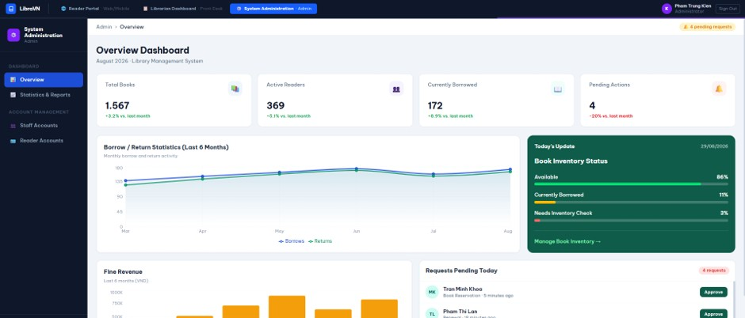
7.3.1 Homepage Admin

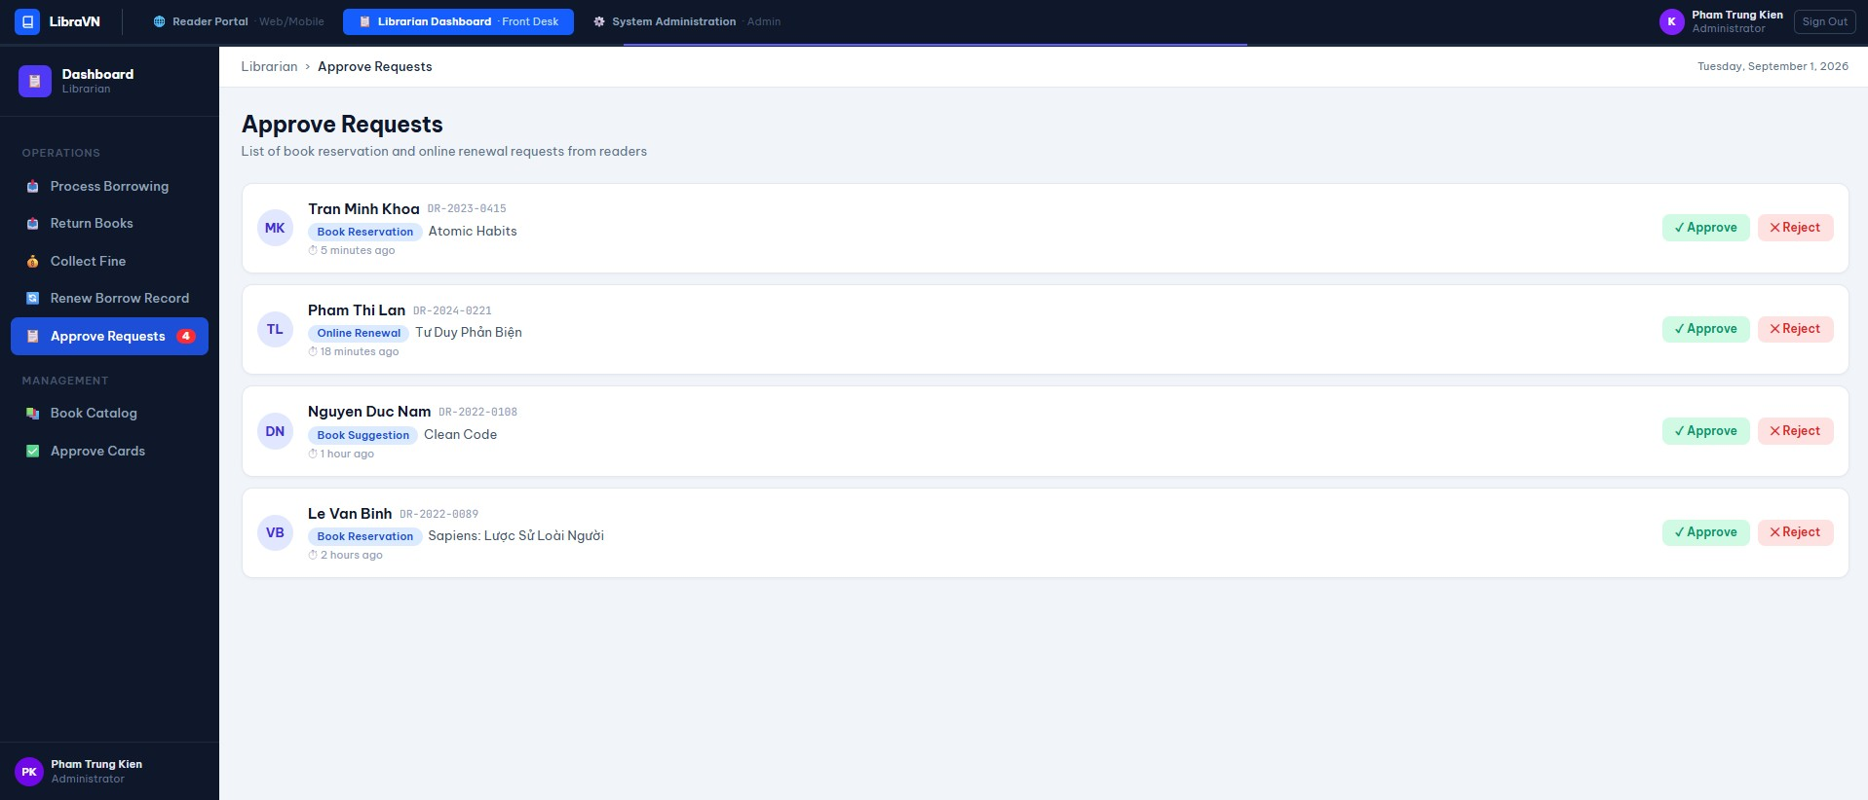
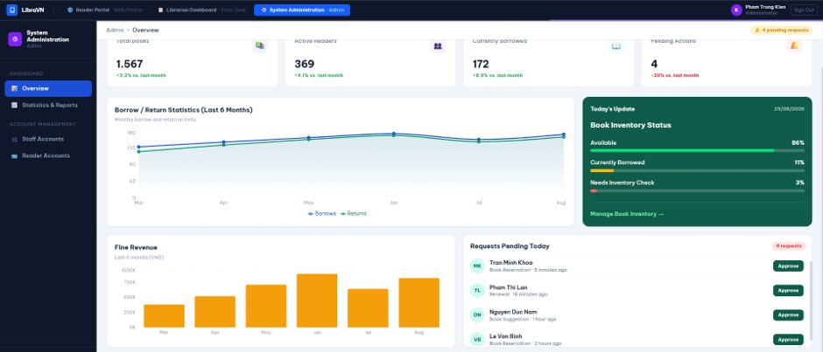
7.3.2 Approve Requests

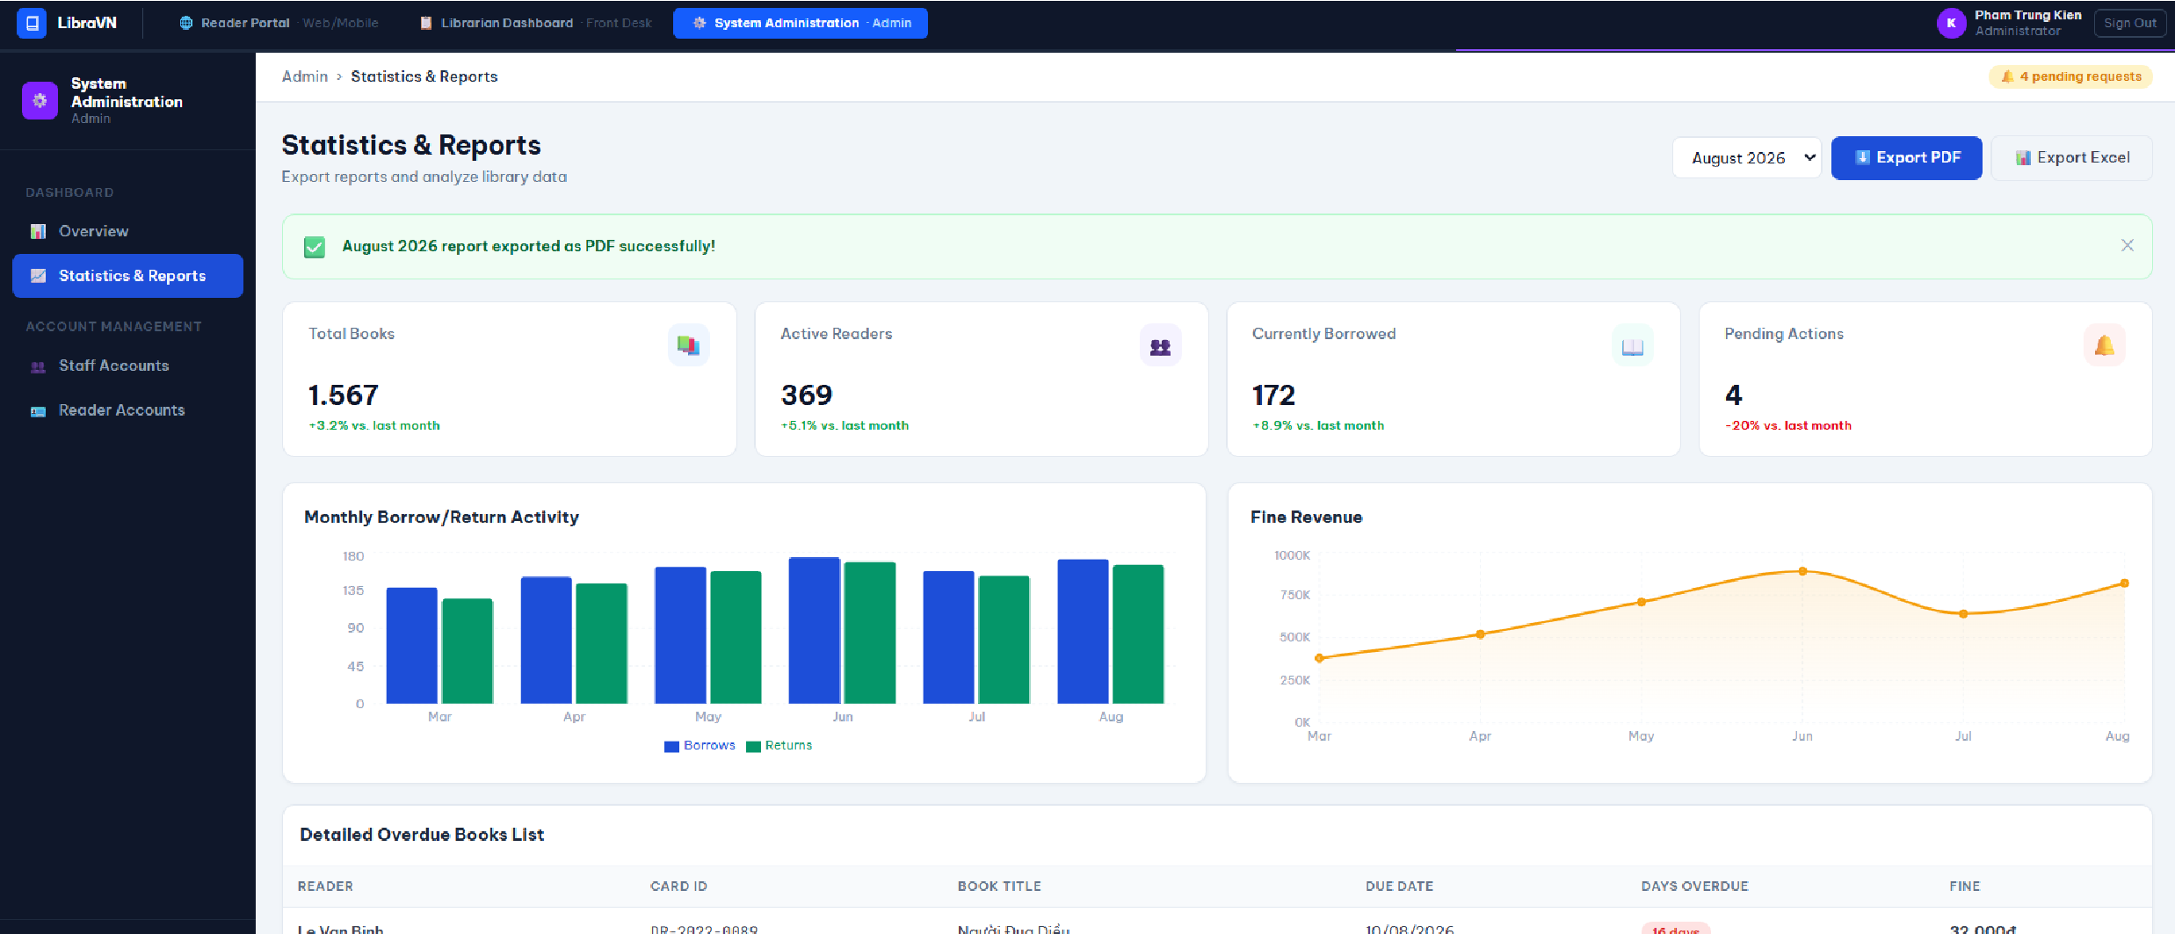
7.3.3 Statistics & Reports

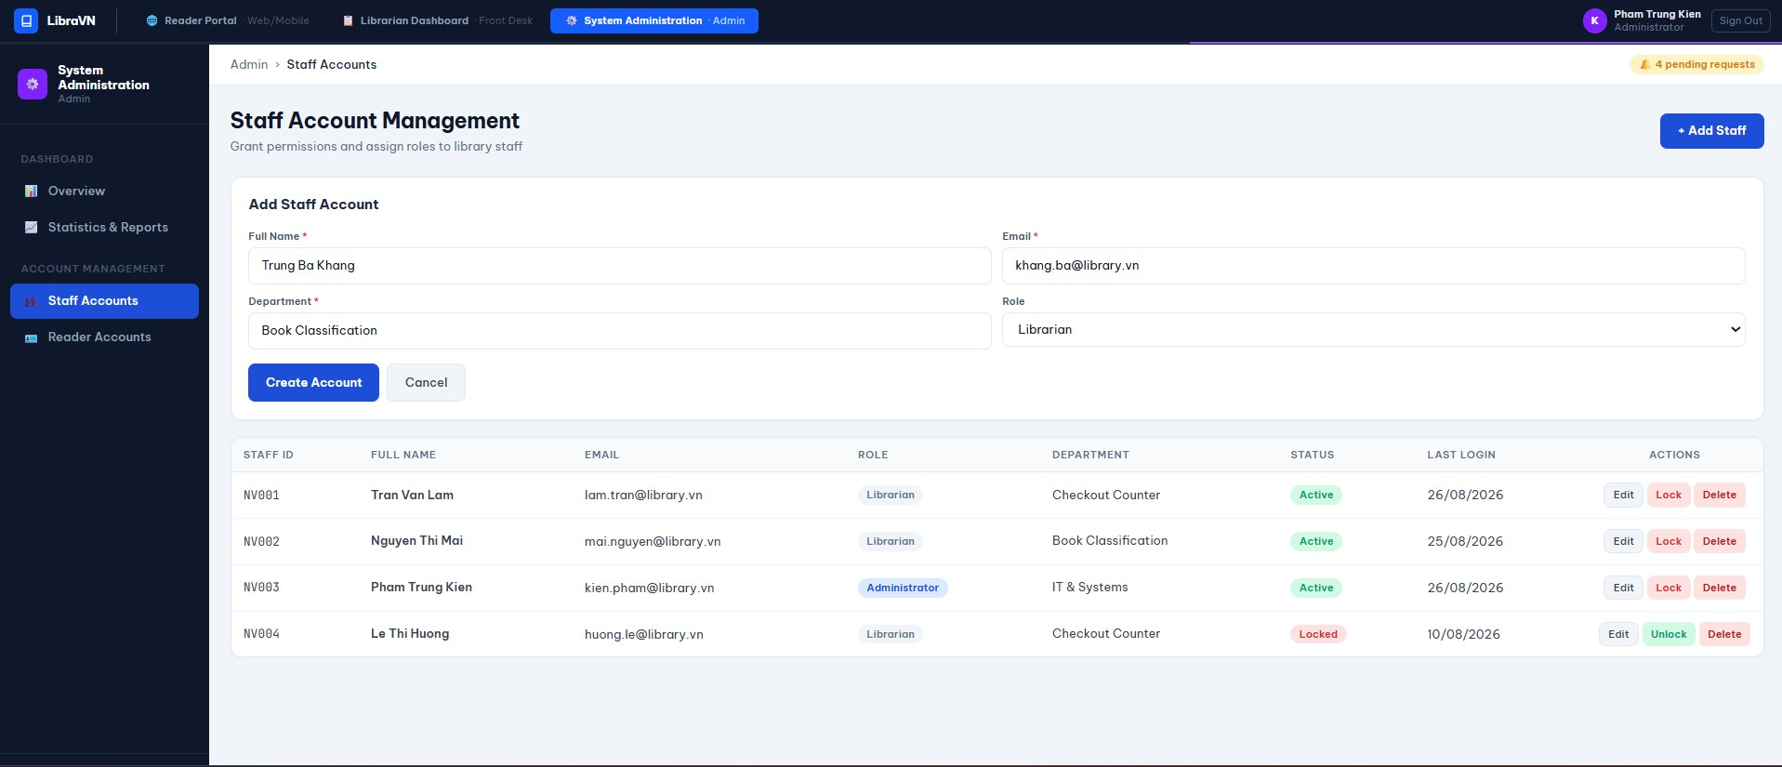
7.3.4 Staff Accounts

